
DITSOBOTLA LOCAL MUNICIPALITY

QUOTATION NO: DLM/SCM/2026/03/COM
ADVERTISEMENT FOR SUPPLY AND DELIVERY OF MATERIAL AT DITSOBOTLA LOCAL MUNICIPALITY

NAME OF BIDDER: |  | Bidder VAT registered?  ☐ Yes ☐ No
TOTAL BID PRICE (INCL VAT): (Brought forward from MBD 3.1) |  | R

Please note that it is compulsory for all service providers to complete the above required information.

Closing Date and Time: 15 May 2026 @ 12:00

TABLE OF CONTENTS

1. BID CHECKLIST
2. SPECIAL CONDITIONS OF BID
3. BID DECLARATION
4. RESOLUTION TAKEN BY THE BOARD OF DIRECTORS / MEMBERS / PARTNERS
5. RESOLUTION TAKEN BY THE BOARD OF DIRECTORS OF A CONSORTIUM OR JOINT VENTURE
6. INVITATION TO BID (MBD 1)
7. TAX CLEARANCE REQUIREMENTS (MBD 2)
8. PRICING SCHEDULE – FIRM PRICES (MBD 3.1)
9. PREVIOUS WORK EXPERIENCE OF A SIMILAR NATURE
10. DECLARATION OF INTEREST (MBD 4)
11. DECLARATION FOR PROCUREMENT ABOVE R10 MILLION (MBD 5)
12. PREFERENCE POINTS CLAIM FORM – PREFERENTIAL PROCUREMENT REGULATIONS 2022 (MBD 6.1)
13. DECLARATION OF BIDDER'S PAST SUPPLY CHAIN MANAGEMENT PRACTICES (MBD 8)
14. CERTIFICATE OF INDEPENDENT BID DETERMINATION (MBD 9)
15. ANNEXURE A: GOVERNMENT PROCUREMENT: GENERAL CONDITIONS OF CONTRACT (JULY 2010)

BID CHECKLIST

Bidders are to use this checklist to ensure that the bid documentation is complete. Indicate that the documentation is complete by completing the table below.
Item | Description | Yes | No | N/A
1. | Is your business registered as accredited prospective supplier with Ditsobotla Local Municipality? | ☐ | ☐ | ☐
2. | Did you read and understand all pages of the bid document? | ☐ | ☐ | ☐
3. | Did you complete the quotation documents in black ink? | ☐ | ☐ | ☐
4. | Did you provide a certified copy of your company registration and VAT registration certificates? | ☐ | ☐ | ☐
5. | Did you provide a certified copy of your identity document (sole proprietorship, Shareholders, Directors or Partners)? | ☐ | ☐ | ☐
6. | Did you provide registration certificate pertaining to the relevant industry, if applicable? | ☐ | ☐ | ☐
7. | Did you provide an original and valid tax clearance certificate? (MBD 2) | ☐ | ☐ | ☐
8. | Did you complete and sign the quotation declaration Form? (Section 3) | ☐ | ☐ | ☐
9. | Where applicable, is there a resolution taken by the Board of Directors/Members/Partners completed and signed? (Section 4) | ☐ | ☐ | ☐
10. | Where applicable, is there a resolution taken by the Board of Directors of a Consortium or Joint Venture completed and signed? (Section 5) | ☐ | ☐ | ☐
11. | Is invitation to quotation completed and signed? (MBD 1) | ☐ | ☐ | ☐
12. | Is the Declaration of Interest completed and signed? (MBD 4) | ☐ | ☐ | ☐
13. | Is the Declaration of Bidder's Past Supply Management Practices completed and signed? (MBD 8) | ☐ | ☐ | ☐
14. | Is the Certificate of Independent Bid Determination completed and signed? (MBD 9) | ☐ | ☐ | ☐
15. | Did you complete and sign the Previous Work Experience of a Similar Nature section? (Section 9) | ☐ | ☐ | ☐
16. | Is the Preference Points Claim Form (MBD 6.1) completed and signed? | ☐ | ☐ | ☐
17. | Did you complete the specific goals for the quotation and points claimed as per the table in MBD 6.1? | ☐ | ☐ | ☐
18. | Does the product/service offered conform to the quotation specifications? | ☐ | ☐ | ☐
19. | Is the Pricing Schedule completed? (MBD 3.1) | ☐ | ☐ | ☐

SPECIAL CONDITIONS OF BID
1. The Municipality's document must be kept as supplied and submitted with all schedules / forms fully completed.
2. Any other documents, certificates etc. must be attached as an annexure to the official Municipal document.
3. Where the Municipality's official document is taken apart and not submitted as supplied, the bid might be rejected.
4. Schedules / forms not duly completed and signed by the bidder will result in a bid not being considered.
5. All Forms of Special Conditions in Specifications should be included.
6. The bid document must be completed in black ink, and prices must be VAT inclusive, unless otherwise specified.
7. The lowest or any Bid will not necessarily be accepted, and Ditsobotla Local Municipality reserves the right to accept the whole or any portion of a Bid.
8. All prices and details must be legible to ensure the bid will be considered for adjudication.
9. Corrections may not be made by means of correction fluid (Tip-Ex or similar). In the event of a mistake, it should be crossed out in ink and accompanied by a full signature at each alteration.

A. RETURNABLE DOCUMENTS
NB: FAILURE TO ATTACH THE BELOW DOCUMENTS WILL LEAD TO DISQUALIFICATION OF BIDS
• Copies of CC/Company registration certificates
• Certified copy of Identity Document of Director(s)/Shareholder(s) – not older than three months
• Valid Tax Compliance PIN status of the Company
• Central Supplier Database (Confirmation of registration)
• Letter confirming banking details of the company – not older than three months
• Original proof of Municipal rates/services of the Company, or copy of valid lease agreement
• Letter from tribal authority / Proof of Residence
• In case of a joint venture, a joint venture agreement must be attached (sworn affidavit not acceptable).
• No bid forwarded by e-mail, telegram, telex, facsimile or similar apparatus will be considered.
• Late bids shall not be admitted for consideration.
Bids must be deposited in the bid box at: 1st Floor Room No. 12 Records, Ditsobotla Local Municipality; Cnr. Dr Nelson Mandela & Transvaal, Lichtenburg, 2740 on or before 12:00 on TUESDAY 15TH MAY 2026. Bids must be submitted in a sealed envelope properly marked with the bid number and description.

BID DECLARATION

I/we Mr./Mrs./Miss. ______________________________ duly assigned to represent the bidder for the purpose of this bid, hereby bid to supply the goods and/or render services as described.

1. I/we agree to supply the goods and/or render services described in the attached documents to the Ditsobotla Local Municipality on terms and conditions stipulated in this bid at the prices reflected in the Pricing Schedule.
2. I/we agree that this offer shall remain valid for a period of 30 days commencing from the closing date and time of this bid.
3. This bid and its acceptance shall be subject to the terms and conditions contained in the Ditsobotla Local Municipality Supply Chain Management Policy.
4. I/we declare that I/we have participation / no participation in the submission of any other offer for the supplies/services described in the attached documents.

Name of Bidder: | Signature:
Capacity: | Date:

RESOLUTION – BOARD OF DIRECTORS / MEMBERS / PARTNERS

Resolution of a meeting of the Board of Directors / Members / Partners of:

Name of Bidder:

Held at (Place): | Date:

RESOLVED THAT:

1. The enterprise submits a Bid to the Ditsobotla Local Municipality in respect of the following project:
ADVERTISEMENT FOR SUPPLY AND DELIVERY OF MATERIAL- DLM/SCM/2026/03/COM

2. Mr/Mrs/Ms _____________________________ in his/her capacity as _____________________________ and who will sign as follows:

Specimen Signature: ___________________________________________

be hereby authorised to sign the Bid and all other documents and correspondence in connection with and relating to the Bid.
Note: The resolution must be signed by all directors or members/partners of the bidding enterprise.

 | Name | Capacity | Signature
1
2
3
4
5
6

Enterprise Stamp

RESOLUTION – CONSORTIUM OR JOINT VENTURE

Resolution of a meeting of the Board of Directors / Members / Partners of:

Name of Bidder:

Held at (Place): | Date:

RESOLVED THAT:

1. The enterprise submits a Bid to the Ditsobotla Local Municipality:
DLM/SCM/2026/03/COM: ADVERTISEMENT FOR SUPPLY AND DELIVERY OF MATERIAL

As a Consortium/Joint Venture comprising (list all legally correct full names and registration numbers):

Enterprise 1 – Name & Reg. No.:

Enterprise 2 – Name & Reg. No.:

2. Mr/Mrs/Ms _____________________________ in his/her capacity as _____________________________, be authorised to sign the Bid on behalf of the Consortium/Joint Venture.

Specimen Signature: ___________________________________________

Note: The resolution must be signed by all directors or members/partners.

 | Name | Capacity | Signature
1
2
3
4
5
6

INVITATION TO BID (MBD 1)

YOU ARE HEREBY INVITED TO BID FOR REQUIREMENTS OF DITSOBOTLA LOCAL MUNICIPALITY
BID NUMBER: | DLM/SCM/2026/03/COM
CLOSING DATE AND TIME: | 15th May 2026 @ 12H00
BID DESCRIPTION: | ADVERTISEMENT FOR SUPPLY AND DELIVERY OF MATERIAL

The Successful bidder will be required to fill in and sign a written Contract Form (MDB 7).
NB: Bids must be deposited in the bid box at: 1st Floor Room No. 12 Records Office, Cnr Dr Nelson Mandela and Transvaal, Lichtenburg, on or before the closing date and time. No bid offers will be accepted via e-mail, facsimile or telegram.
THE FOLLOWING PARTICULARS MUST BE FURNISHED
(FAILURE TO DO SO MAY RESULT IN YOUR BID BEING DISQUALIFIED)

NAME OF BIDDER:

POSTAL ADDRESS:

STREET ADDRESS:

TELEPHONE NUMBER (Code + Number):

CELLPHONE NUMBER:

FACSIMILE NUMBER (Code + Number):

E-MAIL ADDRESS:

VAT REGISTRATION NUMBER:

Has an original and valid Tax Compliance PIN: | ☐ YES ☐ NO

Signature: | Date:
Position: | Name of Bidder:

TOTAL BID PRICE: | TOTAL NUMBER OF ITEMS OFFERED:

ENQUIRIES REGARDING BIDDING PROCEDURE:
Municipality: | DLM
Department: | BTO
Contact Person: | Tshidi Dube
Email: | tshididube@gmail.com

TAX CLEARANCE REQUIREMENTS (MBD 2)

It is a condition of bid that the taxes of the successful bidder must be in order, or that satisfactory arrangements have been made with SARS to meet the bidder's tax obligations.

1. In order to meet this requirement, bidders are required to complete in full the attached form TCC 001 "Application for a Tax Clearance Certificate" and submit it to any SARS branch office nationally. The Tax Clearance Certificate Requirements are also applicable to foreign bidders.
2. SARS will furnish the bidder with a Tax Clearance Certificate that will be valid for a period of 1 (one) year from the date of approval.
3. The original Tax Clearance Certificate must be submitted together with the bid. Failure to submit the original and valid Tax Clearance Certificate will result in the invalidation of the bid. Certified copies will not be acceptable.
4. In bids where Consortia / Joint Ventures / Sub-contractors are involved, each party must submit a separate Tax Clearance Certificate.
5. Copies of the TCC 001 form are available from any SARS branch office nationally or on the website www.sars.gov.za.
6. Applications for the Tax Clearance Certificate may also be made via eFiling at www.sars.gov.za.

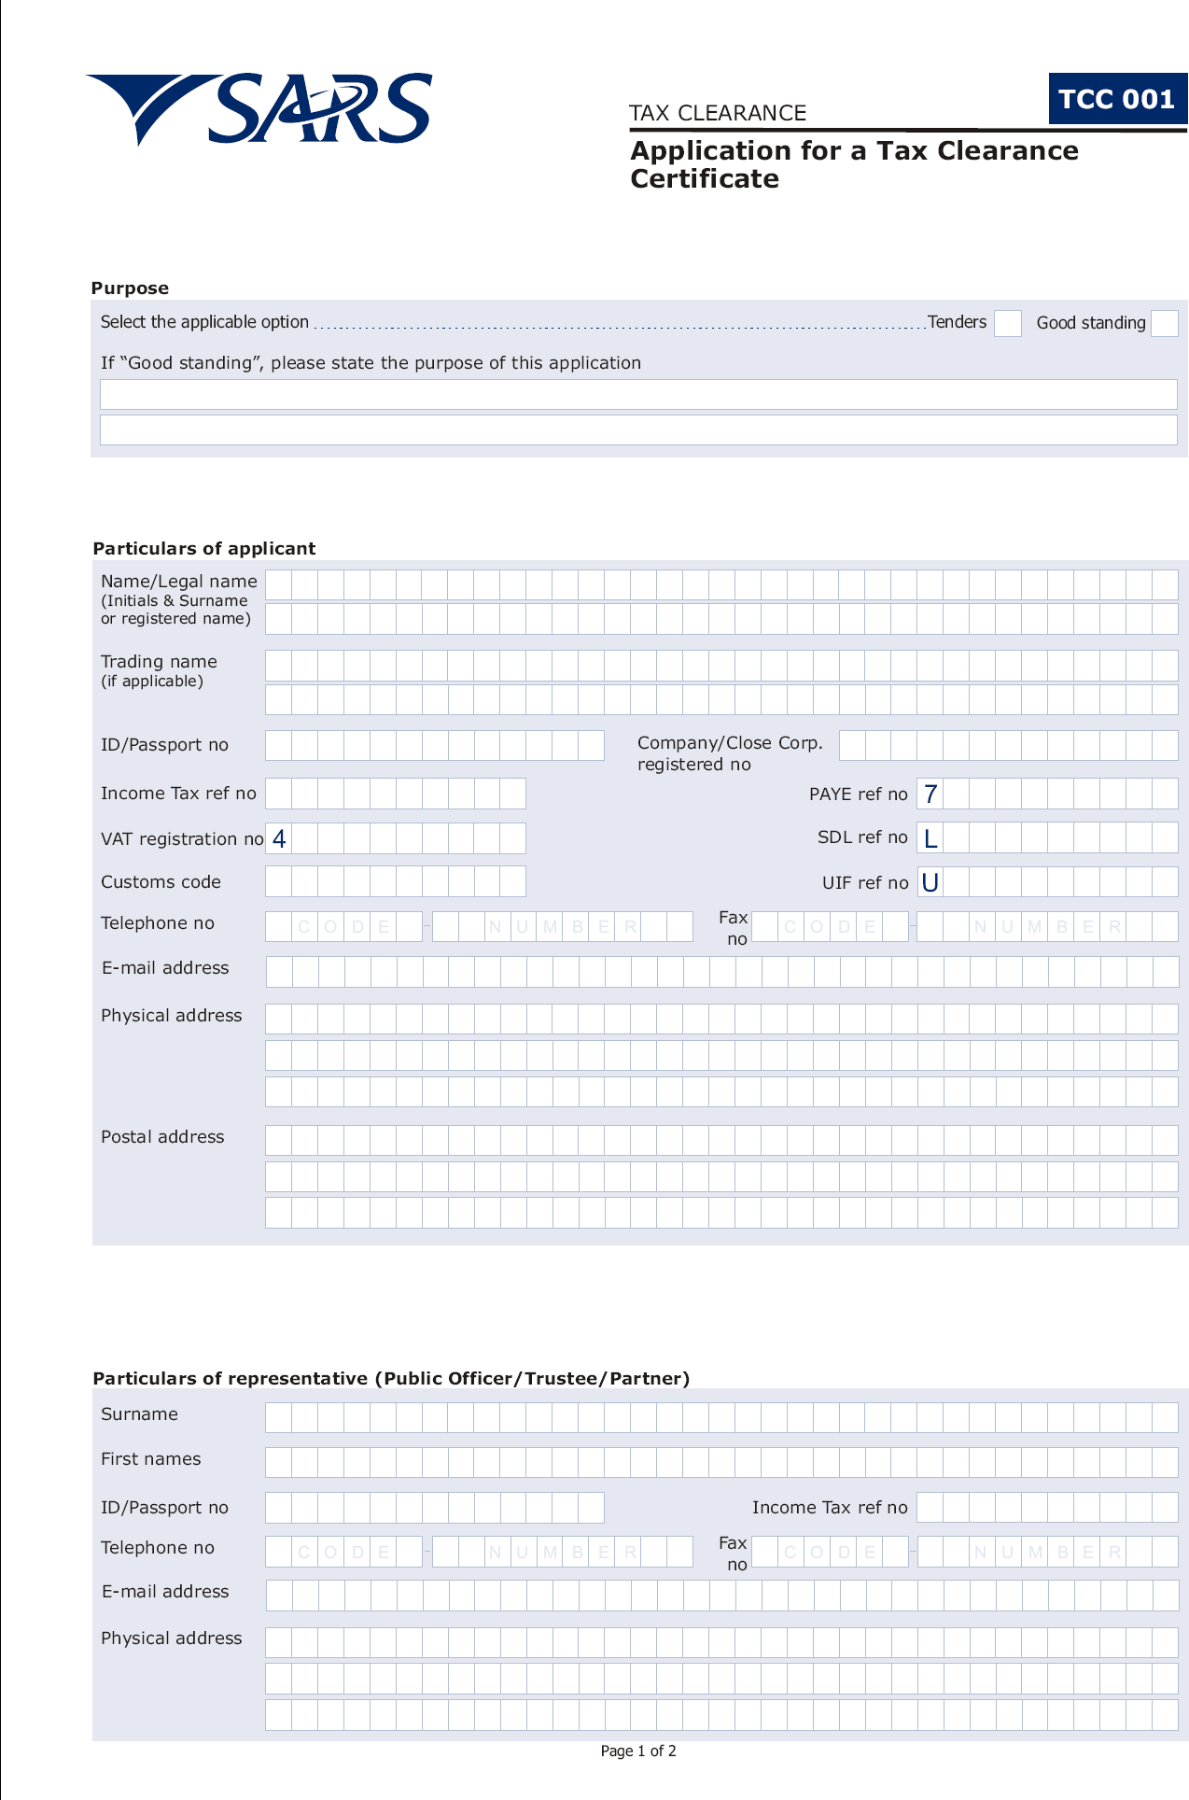
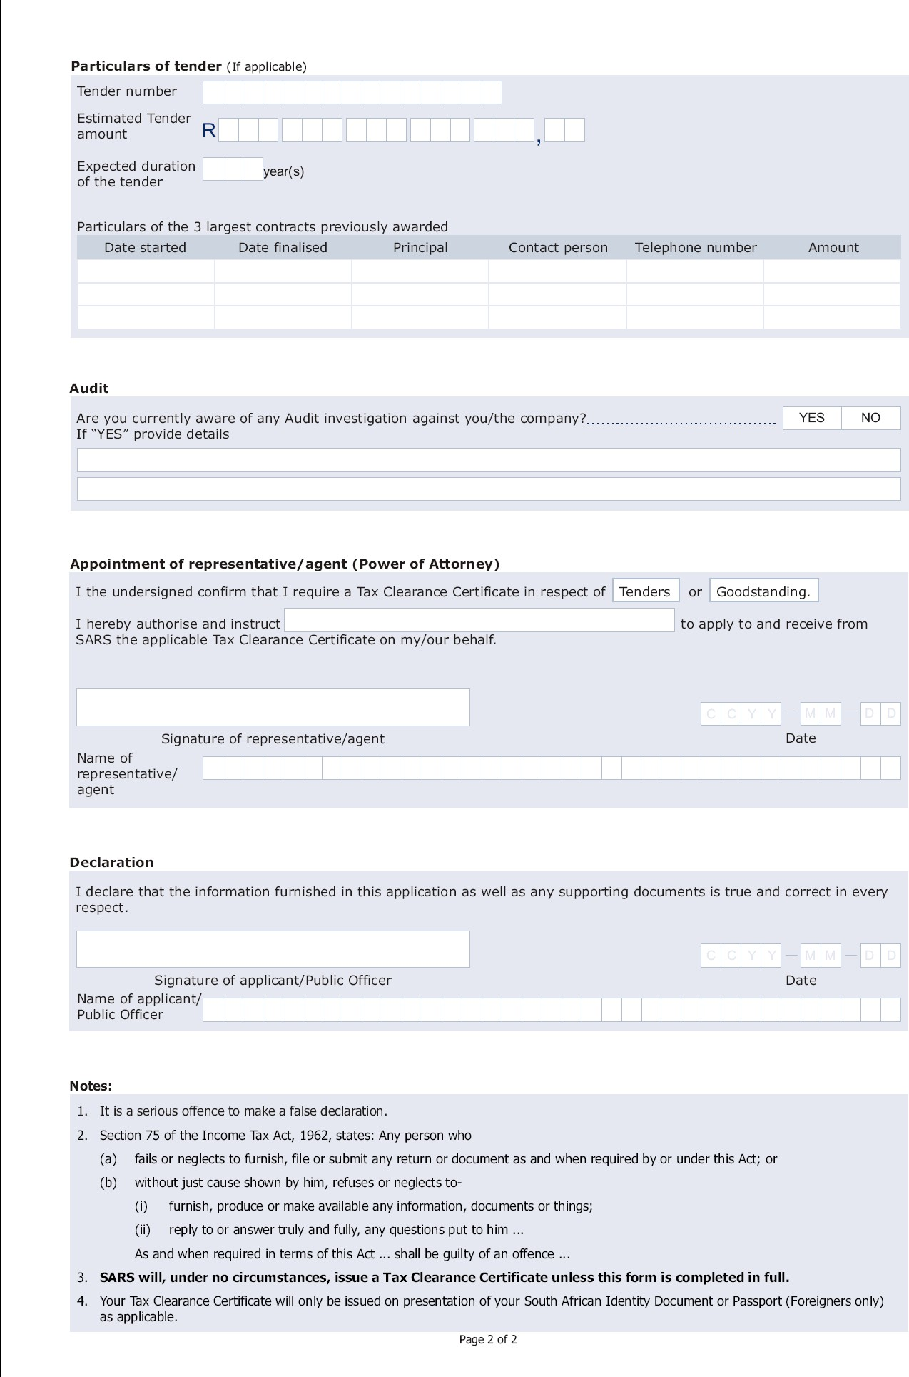
PRICING SCHEDULE – FIRM PRICES (MBD 3.1)
Name of Bidder:

Bid number: | DLM/SCM/2026/03/COM
Closing day and time: | 15th May 2026 @ 12H00
Bid description: | ADVERTISEMENT FOR SUPPLY AND DELIVERY OF MATERIAL

OFFER TO BE VALID FOR 30 DAYS FROM THE CLOSING DATE OF BID.

SCOPE AND PRICING
Description | Qty | Amount
Material  - Refuse bags  - Goggles  - Gloves  - Rakes  - Dust Masks  - Litter Pickers  - Brooms  - Wheel Barrows  - Wheat Killer Poison | 80 Bales (750x 950x 30 microns)  100  200 cry Fish  50  40 boxes  4 boxes  20 Pavement Brooms  10 steel 65Litre capacity, featuring a 1.2mm to 1.6mm steel pan and a 32, steel frame for heavy-duty, SABS -approved performance  2x25 liters
TOTAL NET QUOTE (VAT EXCL) |  | R
VAT AMOUNT @ 15% |  | R
TOTAL QUOTATION PRICE (INCLUDING VAT) – carries forward to front cover |  | R

Required by: | At (Location):

Does offer comply with the specifications? | ☐ YES ☐ NO

If not to specification, indicate deviation(s):

Period required for delivery: | Delivery: ☐ Firm ☐ Not Firm
Note: All delivery costs must be included in the quotation price.

PREVIOUS WORK EXPERIENCE OF A SIMILAR NATURE

List and attach certified copies of main work experience of a similar nature to this bid, successfully executed and completed (or on-going) in the last five (5) years:

No | Institution / Client | Project Description | Date Started | Date Completed | Project Value (R) | Contact Person & Details
1
2
3
4
5
6
7
8
9
10

Representatives of the Ditsobotla Local Municipality are authorized to contact the above references to verify the correctness of the information supplied.

Signature: | Date:
Position: | Name of Bidder:

DECLARATION OF INTEREST (MBD 4)

No bid will be accepted from persons in the service of the state. * Any person having a kinship with persons in the service of the state must declare their position in relation to the evaluating/adjudicating authority.

Please complete the following questionnaire:
Full Name:

Identity Number:

Company Registration Number:

Tax Reference Number:

VAT Registration Number:

Are you presently in the service of the state? | ☐ YES ☐ NO
If yes, furnish particulars:

Have you been in the service of the State for the past twelve months? | ☐ YES ☐ NO
If yes, furnish particulars:

Do you have any relationship (family, friend, other) with persons in the service of the state who may be involved with the evaluation and/or adjudication of this bid? | ☐ YES ☐ NO
If yes, furnish particulars:

Are you aware of any relationship between a bidder and any persons in the service of the state who may be involved with the evaluation and/or adjudication of this bid? | ☐ YES ☐ NO
If yes, furnish particulars:

Are any of the company's directors, managers, principal shareholders or stakeholders in service of the state? | ☐ YES ☐ NO
If yes, furnish particulars:

Are any spouse, child or parent of the company's directors, managers, principal shareholders or stakeholders in service of the state? | ☐ YES ☐ NO
If yes, furnish particulars:

CERTIFICATION

I, THE UNDERSIGNED (NAME): ________________________________________________________________

CERTIFY THAT THE INFORMATION FURNISHED ON THIS DECLARATION FORM IS CORRECT.
I ACCEPT THAT THE STATE MAY ACT AGAINST ME SHOULD THIS DECLARATION PROVE TO BE FALSE.

Signature: | Date:
Position: | Name of Bidder:

DECLARATION FOR PROCUREMENT ABOVE R10 MILLION (MBD 5)

For all procurement expected to exceed R10 million (all applicable taxes included), bidders must complete the following questionnaire:

1. Are you by law required to prepare annual financial statements for auditing? (If yes, submit audited annual financial statements for the past three years.) | ☐ YES ☐ NO
If yes, furnish particulars:

2. Do you have any outstanding undisputed commitments for municipal services towards any municipality for more than three months or any other service provider in respect of which payment is overdue for more than 30 days? | ☐ YES ☐ NO
If yes, furnish particulars:

3. Has any contract been awarded to you by an organ of state during the past five years, including any material non-compliance or dispute concerning the execution of such contract? | ☐ YES ☐ NO
If yes, furnish particulars:

4. Will any portion of goods or services be sourced from outside the Republic, and if so, whether any portion of payment from the municipality is expected to be transferred out of the Republic? | ☐ YES ☐ NO
If yes, furnish particulars:

CERTIFICATION

I, THE UNDERSIGNED (NAME): ________________________________________________________________

CERTIFY THAT THE INFORMATION FURNISHED ON THIS DECLARATION FORM IS CORRECT.
I ACCEPT THAT THE STATE MAY ACT AGAINST ME SHOULD THIS DECLARATION PROVE TO BE FALSE.

Signature: | Date:
Position: | Name of Bidder:

PREFERENCE POINTS CLAIM FORM (MBD 6.1) – Preferential Procurement
PREFERENCE POINTS CLAIM FORM IN TERMS OF THE PREFERENTIAL PROCUREMENT REGULATIONS 2022
This preference form must form part of all tenders invited. It contains general information and serves as a claim form for preference points for specific goals.
NB: BEFORE COMPLETING THIS FORM, TENDERERS MUST STUDY THE GENERAL CONDITIONS, DEFINITIONS AND DIRECTIVES APPLICABLE IN RESPECT OF THE TENDER AND PREFERENTIAL PROCUREMENT REGULATIONS, 2022

- GENERAL CONDITIONS
  - The following preference point systems are applicable to invitations to tender:
    - the 80/20 system for requirements with a Rand value of up to R50 000 000 (all applicable taxes included); and
    - the 90/10 system for requirements with a Rand value above R50 000 000 (all applicable taxes included).
  - To be completed by the organ of state
    - The applicable preference point system for this tender is the 80/20 preference point system.
    - 80/20 preference point system will be applicable in this tender. The lowest/ highest acceptable tender will be used to determine the accurate system once tenders are received.
  - Points for this tender (even in the case of a tender for income-generating contracts) shall be awarded for:
- Functionality; and
- Specific Goals.
  - To be completed by the organ of state:
The maximum points for this tender are allocated as follows:
 | POINTS
PRICE | 80
SPECIFIC GOALS | 20
Total points for PRICE and SPECIFIC GOALS | 100

  - Failure on the part of a tenderer to submit proof or documentation required in terms of this tender to claim points for specific goals with the tender, will be interpreted to mean that preference points for specific goals are not claimed.
  - The organ of state reserves the right to require of a tenderer, either before a tender is adjudicated or at any time subsequently, to substantiate any claim in regard to preferences, in any manner required by the organ of state.
- DEFINITIONS
- “tender” means a written offer in the form determined by an organ of state in response to an invitation to provide goods or services through price quotations, competitive tendering process or any other method envisaged in legislation;
- “price” means an amount of money tendered for goods or services, and includes all applicable taxes less all unconditional discounts;
- “rand value” means the total estimated value of a contract in Rand, calculated at the time of bid invitation, and includes all applicable taxes;
- “tender for income-generating contracts” means a written offer in the form determined by an organ of state in response to an invitation for the origination of income-generating contracts through any method envisaged in legislation that will result in a legal agreement between the organ of state and a third party that produces revenue for the organ of state, and includes, but is not limited to, leasing and disposal of assets and concession contracts, excluding direct sales and disposal of assets through public auctions; and
- “the Act” means the Preferential Procurement Policy Framework Act, 2000 (Act No. 5 of 2000).
- FORMULAE FOR PROCUREMENT OF GOODS AND SERVICES
  - POINTS AWARDED FOR PRICE
    - THE 80/20 OR 90/10 PREFERENCE POINT SYSTEMS
A maximum of 80 or 90 points is allocated for price on the following basis:

80/20 or 90/10

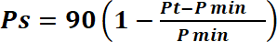
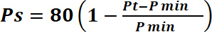 or
Where
Ps | = | Points scored for price of tender under consideration
Pt | = | Price of tender under consideration
Pmin | = | Price of lowest acceptable tender

  - FORMULAE FOR DISPOSAL OR LEASING OF STATE ASSETS AND INCOME GENERATING PROCUREMENT
    - POINTS AWARDED FOR PRICE

A maximum of 80 or 90 points is allocated for price on the following basis:

80/20 or 90/10

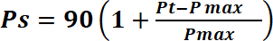
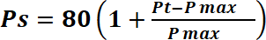 or

Where
 | Ps  Pt | =  = | Points scored for price of tender under consideration  Price of tender under consideration
 | Pmax | = | Price of highest acceptable tender

- POINTS AWARDED FOR SPECIFIC GOALS
  - In terms of Regulation 4(2); 5(2); 6(2) and 7(2) of the Preferential Procurement Regulations, preference points must be awarded for specific goals stated in the tender. For the purposes of this tender the tenderer will be allocated points based on the goals stated in table 1 below as may be supported by proof/ documentation stated in the conditions of this tender:
  - In cases where organs of state intend to use Regulation 3(2) of the Regulations, which states that, if it is unclear whether the 80/20 or 90/10 preference point system applies, an organ of state must, in the tender documents, stipulate in the case of—
    - an invitation for tender for income-generating contracts, that either the 80/20 or 90/10 preference point system will apply and that the highest acceptable tender will be used to determine the applicable preference point system; or

    - any other invitation for tender, that either the 80/20 or 90/10 preference point system will apply and that the
lowest acceptable tender will be used to determine the applicable preference point system,
then the organ of state must indicate the points allocated for specific goals for both the 90/10 and 80/20 preference point system.
Functionality
CRITERIA | SUB-CRITERIA | Number of points  allocated (80/20  system)  (To be completed by the  organ of state) | Number of points claimed (80/20  system)  (To be completed by the tenderer)
SPECIFIC GOALS | Gender | 4
SPECIFIC GOALS | Disability | 4
SPECIFIC GOALS | Youth | 4
SPECIFIC GOALS | Race | 4
 | SUB-CRITERIA | POINT
GENDER | Female | 4
 | Male | 2
 | SUB-CRITERIA | POINT
YOUTH | <35 | 4
 | SUB-CRITERIA | POINT
NATIONALITY | South African  Non-South African | 4  0
 | SUB-CRITERIA | POINT
DISABILITY | Subject to proof of Disability | 4
 | SUB-CRITERIA | POINT
LOCALITY | Ditsobotla Local Municipality | 4
 | Ngaka Modiri Molema | 2
 | North west Province | 1
 | TOTAL SCORE |  | 20

points scored for price as calculated in accordance with sub-regulation (1) of PPPFA regulations of 2022.

Points Allocation
 | POINTS
PRICE | 80
SPECIFIC GOALS | 20
TOTAL | 100

DECLARATION WITH REGARD TO COMPANY/FIRM
Name of company/firm:

Company registration number:

TYPE OF COMPANY/FIRM (tick applicable box):

☐ Partnership/Joint Venture/Consortium
☐ One-person business/Sole Proprietorship
☐ Close Corporation
☐ Public Company
☐ Personal Liability Company (Pty) Ltd
☐ Non-Profit Company
☐ State Owned Company

I, the undersigned, who is duly authorized

to do so on behalf of the company/firm, certify that the points claimed, based on the specific goals as advised in the tender, qualifies the company/firm for the preferences shown and I acknowledge that the information furnished is true and correct.

Signature: | Date:
Position: | Name of Bidder:

SURNAME AND NAME:

ADDRESS:

DECLARATION OF BIDDER'S PAST SUPPLY CHAIN MANAGEMENT PRACTICES (MBD 8)
This serves as a declaration ensuring that when goods and services are procured, all reasonable steps are taken to combat the abuse of the supply chain management system. The bid of any bidder may be rejected if that bidder or any of its directors have abused the SCM system, been convicted for fraud or corruption in the past five years, or been listed in the Register for Tender Defaulters.
Item | Question | Yes | No
3.1 | Is the bidder or any of its directors listed on the National Treasury's database as a company or person prohibited from doing business with the public sector? (The Database of Restricted Suppliers resides on www.treasury.gov.za) | Yes ☐ | No ☐
3.1.1 | If so, furnish particulars:
3.2 | Is the bidder or any of its directors listed on the Register for Tender Defaulters in terms of section 29 of the Prevention and Combating of Corrupt Activities Act (No 12 of 2004)? (Register accessible on www.treasury.gov.za) | Yes ☐ | No ☐
3.2.1 | If so, furnish particulars:
3.3 | Was the bidder or any of its directors convicted by a court of law for fraud or corruption during the past five years? | Yes ☐ | No ☐
3.3.1 | If so, furnish particulars:
3.4 | Does the bidder or any of its directors owe any municipal rates and taxes or municipal charges that are in arrears for more than three months? | Yes ☐ | No ☐
3.4.1 | If so, furnish particulars:
3.5 | Was any contract between the bidder and the municipality or any other organ of state terminated during the past five years on account of failure to perform? | Yes ☐ | No ☐
3.5.1 | If so, furnish particulars:

CERTIFICATION

I, THE UNDERSIGNED (FULL NAME): ________________________________________________________________

CERTIFY THAT THE INFORMATION FURNISHED ON THIS DECLARATION FORM IS TRUE AND CORRECT.
I ACCEPT THAT, IN ADDITION TO CANCELLATION OF A CONTRACT, ACTION MAY BE TAKEN AGAINST ME SHOULD THIS DECLARATION PROVE TO BE FALSE.

Signature: | Date:
Position: | Name of Bidder:

CERTIFICATE OF INDEPENDENT BID DETERMINATION (MBD 9)

Section 4(1)(b)(iii) of the Competition Act No. 89 of 1998 prohibits collusive bidding. Bid rigging is a per se prohibition meaning that it cannot be justified under any grounds.

CERTIFICATE OF BID DETERMINATION

I, the undersigned, in submitting the accompanying bid:

DLM/SCM/2026/03/COM: ADVERTISEMENT FOR SUPPLY AND DELIVERY OF MATERIAL

in response to the invitation for the bid made by:
Ditsobotla Local Municipality
do hereby make the following statements that I certify to be true and complete in every respect:

I certify, on behalf of: that: (Name of Bidder)

- I have read and I understand the contents of this Certificate;

- I understand that the accompanying bid will be disqualified if this Certificate is found not to be true and complete in every respect;

- I am authorized by the bidder to sign this Certificate, and to submit the accompanying bid, on behalf of the bidder;
- Each person whose signature appears on the accompanying bid has been authorized by the bidder to determine the terms of, and to sign, the bid, on behalf of the bidder;

- For the purposes of this Certificate and the accompanying bid, I understand that the word “competitor” shall include any individual or organization, other than the bidder, whether or not affiliated with the bidder, who:
  - has been requested to submit a bid in response to this bid invitation;
  - could potentially submit a bid in response to this bid invitation, based on their qualifications, abilities or experience; and
  - provides the same goods and services as the bidder and/or is in the same line of business as the bidder
- The bidder has arrived at the accompanying bid independently from, and without consultation, communication, agreement or arrangement with any competitor. However communication between partners in a joint venture or consortium* will not be construed as collusive bidding.

- In particular, without limiting the generality of paragraphs 6 above, there has been no consultation, communication, agreement or arrangement with any competitor regarding:
  - prices;
  - geographical area where product or service will be rendered (market allocation)
  - methods, factors or formulas used to calculate prices;
  - the intention or decision to submit or not to submit, a bid;
  - the submission of a bid which does not meet the specifications and conditions of the bid; or
  - bidding with the intention not to win the bid.
- In addition, there have been no consultations, communications, agreements or arrangements with any competitor regarding the quality, quantity, specifications and conditions or delivery particulars of the products or services to which this bid invitation relates.

- The terms of the accompanying bid have not been, and will not be, disclosed by the bidder, directly or indirectly, to any competitor, prior to the date and time of the official bid opening or of the awarding of the contract.

- I am aware that, in addition and without prejudice to any other remedy provided to combat any restrictive practices related to bids and contracts, bids that are suspicious will be reported to the Competition Commission for investigation and possible imposition of administrative penalties in terms of section 59 of the Competition Act No. 89 of 1998 and or may be reported to the National Prosecuting Authority (NPA) for criminal investigation and or may be restricted from conducting business with the public sector for a period not exceeding ten (10) years in terms of the Prevention and Combating of Corrupt Activities Act No. 12 of 2004 or any other applicable legislation.
………………………………………….
Signature
…………………………………..
Date
………………………………………….
Position
…………………….…………………………………………… Name of Bidder
Signature: | Date:
Position: | Name of Bidder:

ANNEXURE A: GOVERNMENT PROCUREMENT – GENERAL CONDITIONS OF CONTRACT (July 2010)

THE NATIONAL TREASURY | Republic of South Africa

1. Definitions
Key terms as defined: Closing time, Contract, Contract price, Corrupt practice, Day, Delivery, Force majeure, Fraudulent practice, GCC, Goods, Purchaser, Republic, Services, Supplier, and others.
2. Application
These general conditions apply to all bids, contracts and orders including bids for functional and professional services, sales, hiring, letting, and the granting or acquiring of rights.
3. General
The purchaser shall not be liable for expense incurred in the preparation and submission of a bid. Invitations to bid are published in local media and on the municipal website.
4. Standards
The goods supplied shall conform to the standards mentioned in the bidding documents and specifications.
5. Use of Contract Documents
The supplier shall not, without the purchaser's prior written consent, disclose the contract or any provision thereof to any person other than a person employed by the supplier in the performance of the contract.
6. Patent Rights
The supplier shall indemnify the purchaser against all third-party claims of infringement of patent, trademark, or industrial design rights. Intellectual and patent rights of documents developed vest in the municipality.
7. Performance Security
Within 30 days of contract award, the successful bidder shall furnish performance security as specified. Performance security is discharged within 30 days of completion of obligations.
8. Inspections, Tests and Analyses
All pre-bidding testing is for the account of the bidder. Goods that do not comply with contract requirements may be rejected. Costs of tests are borne by the relevant party depending on results.
9. Packing
The supplier shall provide sufficient packing to prevent damage or deterioration during transit to the final destination.
10. Delivery and Documents
Delivery of goods and arrangements for shipping shall be made by the supplier in accordance with terms specified in the contract.
11. Insurance
Goods shall be fully insured against loss or damage incidental to manufacture, transportation, storage and delivery.
12. Transportation
If a price other than an all-inclusive delivered price is required, this shall be specified.
13. Incidental Services
The supplier may be required to provide on-site assembly, tools, manuals, maintenance, and training as part of the contract obligations.
14. Spare Parts
The supplier may be required to provide spare parts and advance notification of termination of production.
15. Warranty
The supplier warrants goods are new, unused, of the most recent models with no defects. Warranty is valid for 12 months after delivery or 18 months from shipment, whichever is earlier.
16. Payment
Payments shall be made promptly, no later than 30 days after submission of an invoice. Payment is made in Rand unless otherwise stipulated.
17. Prices
Prices charged shall not vary from quoted prices except for any price adjustments authorized by the purchaser.
18. Variation Orders
Changes up to 15% of the total contract value may be instructed. Contractors may be approached to reduce unit prices for measurable quantities.
19–20. Assignment and Subcontracts
The supplier shall not assign obligations without the purchaser's prior written consent. All subcontracts must be notified to the purchaser in writing.
21. Delays in Performance
The supplier must notify the purchaser promptly of any delays. The purchaser may extend the delivery time or impose penalties.
22. Penalties
If the supplier fails to deliver within the specified period, penalties calculated at the current prime interest rate per day of delay may be deducted.
23. Termination for Default
The purchaser may terminate the contract if the supplier fails to deliver, fails to perform obligations, or has engaged in corrupt or fraudulent practices.
24. Anti-dumping and Countervailing Duties
The State is not liable for provisional payments, anti-dumping or countervailing duties imposed after the date of bid.
25. Force Majeure
The supplier shall not be liable for forfeiture or termination if failure to perform is the result of a force majeure event, provided prompt written notification is given.
26. Termination for Insolvency
The purchaser may terminate the contract at any time if the supplier becomes bankrupt or insolvent, without compensation to the supplier.
27. Settlement of Disputes
Parties shall first attempt to resolve disputes by mutual consultation. If unresolved within 30 days, mediation may be commenced. Court proceedings are a final recourse.
28. Limitation of Liability
The supplier is not liable for indirect or consequential loss. Aggregate liability shall not exceed the total contract price.
29–35. Governing Language, Applicable Law, Notices, Taxes, Transfer, Amendment, and Restrictive Practices
The contract is written in English and interpreted in accordance with South African law. No contract shall be concluded with bidders whose tax or municipal obligations are in arrears. Collusive bidding is prohibited and may result in referral to the Competition Commission.

